A small polite note on late collections: Please ensure that you collect your child by the time your session finishes. Dropping your child off late does not mean that you can pick them up late. This is because we assign our staff rotas based on when the children have arranged to arrive and leave. Please be considerate to our very hard working staff!

**Staff list**

We have made some staffing changes over the past few months and are very excited to welcome Rosie and Nikkita; both highly qualified and capable practitioners. We are very sad to say goodbye to senior practitioner, Becky Wixley, who has moved onto different challenges.

**What have we been up to?**

The past term has been a busy one for Purple Childcare. We have reached our second birthday, added some highly qualified and experienced staff to our team and made some changes to the building and garden.

Staffing: Although we don’t think that qualifications are the only important factor we are very proud to say that half of our staff now have a degree level or above qualification. This means that we can provide researched based, high quality learning for your children. Please note that we will be assigning our new staff key children in the next couple of weeks. You will always be informed if your key person changes and you can always talk to us if you have any concerns.

Building and garden: We have removed some of the smaller walls in the pre-school to make room for a new arts and crafts space. This will have large acetate sheets on the wall and a wall mounted roll of paper and giant picture frame. In the toddler room we have changed our storage to make it more space efficient and to allow for a cosy book area, a role play space and a messy play area. Our new space has been working very well and toddlers have particularly loved our child-sized sofas! In the baby room we have updated our sleep space to include low sofa beds and are planning to add in a large climbing and exploring structure. Details of changes can be found in our parents’ book in the entrance hall. We would love it if you feel like leaving a comment in our book!

Management team

**Fliss Shapter,** Manager and director. Fliss has an early years professional qualification (EYP, level 6) and 16 years childcare experience.

**Hannah Ross,** SENCo and director. Hannah is a qualified teacher (level 6) and has 15 years childcare experience.

Pre-school team

**Megan Day,** Upper Pre-school lead. Megan is a qualified teacher (level 6) with recent experience in a local reception class. Megan is our curriculum co-ordinator

**Samantha Knight,** Lower pre-school lead. Sam has a childcare based degree (level 6)

**Rosie Johnson,** Pre-school and baby based senior practitioner. Rosie has a childcare based foundation degree (level 5) and 5 years childcare experience

**Chloe Sanders,** pre-school practitioner. Chloe has a level 2 qualification and is currently working towards her level 3.







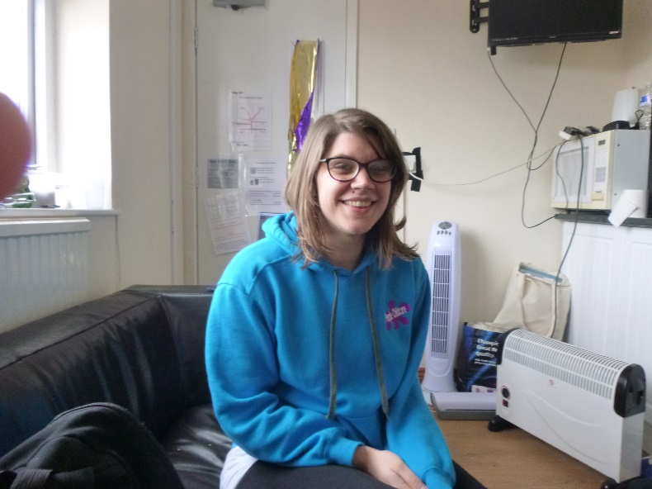

Baby room team

**Lara Norton,** baby room lead and level 3 qualified.

**Rosie Johnson,** level 5 practitioner. Rosie works in the pre-school and baby room

**Julia Klejnert,** baby room practitioner. Julia has a level 2 qualification



Toddler room team

**Kayleigh Pratt**, Deputy manager and toddler room leader. Kay has a level 3 qualification and a wealth of experience. Kay is also part of the leadership team.

**Nikkita Cattelona,** Deputy toddler room lead. Nikkita has a childcare degree (level 6) and 11 years childcare experience.

