Who can I talk too
1. Talk to your child’s Key worker
2. Talk to Gemma Barnes – the SENCo
3. Talk to Felicity Shapter – Manager/safeguarding lead.

The way they communicate and interact either with adults or  other children. | Learning in class or in  a small group or by  themselves. | Learning to manage  their feelings and building relationships with others. | Their physical needs,  including eyesight,  hearing, spatial  awareness, movement etc.
 |  | 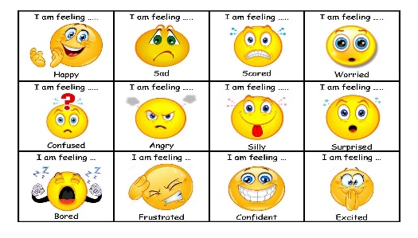 | 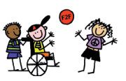
Your child may need help with…

What we offer
Our room leads and staff support children with a range of different needs, but some children need additional support that is different from their peers. The room lead plans for those additional needs and seeks support from others as necessary. i.e support from the SENCo. Our environments are inclusive and enabling. We’ll watch, help & support, check for understanding and track progress. Then, either this support works, and your child is back on track with their peers, or we will need to help some more to cater their educational journey for the best outcomes. If so, we will work closely with you, and make a plan of what to do.
This is called SEN Support
At this point, your child is on the SEN record of provision. Help may be from in nursery or from out of nursery, but we’ll talk about it. If long-term support is needed, then lots of things may happen. We will link with a range of other agencies. We make sure we access the right specialist support for the needs.
We may put a support plan in place for your child. This is to have a more in depth understanding of their needs and to give targets and a catered provision plan moving forwards. This is created and filled in with you and includes views from us, you and other professionals working with your child. Through this we can apply for Early years special educational needs funding. Which enables us to give your child catered 1:1 support from 50-100% of their time at nursery, depending on their needs and the SEND panels decision.
Local offer
The Bristol Local offer is a very valuable source of resources for families and professionals to access regarding what our local authority has to offer children (0-25) with SEND or children who need that extra support. If you need any help navigating the website, please feel free to ask us. https://www.bristol.gov.uk/web/bristol-local-offer
Also, exclusively to Bristol is the DEYO (differentiated early years outcomes). This is a document that works alongside the new development matters but is catered to children who have additional needs across all the 7 areas of learning. Physical development, literacy, mathematics, expressive arts and design, understanding the world, communication and language and personal, social and emotional development. Please ask us if you would like access to a copy or find it on the website www.bristolearlyyears.org.uk. Which is full of plenty of helpful information, including how to access disability living allowance. Which is extra funded support for you and your child.
Speech and language support
We may ask you to get in touch with the speech and language team. They offer a drop-in telephone service to discuss your concerns and to offer you support moving forwards. This is every Thursday 9.45 am – 12.15 pm on 03001245832.
If you would just like general speech and language advice. The hotline is open every Wednesday 9am – 12pm on 07825016335
For general advice upon children with additional needs and the support available, you can contact FLORA (families, local offer, resources and advice) – on 01173526020. Open all weekdays.

Request for involvement forms
If you have concerns about your child’s needs and wish you refer for a specific support. Such as autism support from the Bristol Autism team, an educational psychologist, physio, occupational therapy, You can fill in a single point of entry/request for involvement form. We can do this on your behalf and help you if you need. https://view.officeapps.live.com/op/view.aspx?src=https%3A%2F%2Fcchp.nhs.uk%2Fsites%2Fdefault%2Ffiles%2FUpdated%2520SPE%2520Form%252008.02.21.docx&wdOrigin=BROWSELINK
Progress and support meetings
We will meet you to talk about support, progress, concerns, and next steps planned with you, through the graduated approach (assess, plan, do, review). These meetings will happen based on each child’s specific needs. For example, one child may need frequent meetings to support needs, and others may just need a catch up every so often
EHCPS
We may talk with you about applying for an Education, Health Care Plan (EHCP.) This is a document that moves with your child throughout their time in education and sets out the support they must receive with regards to their needs, education, health and care. You can self-refer or we can refer on your behalf. In line with the SEND Code of Practice (2015) we will work collaboratively alongside other professionals to ensure the most accurate plan is drawn together to cater your child’s holistic needs and get things right for your child more quickly. This will include visits to observe in our setting and contact with you to support the plan. Having an EHCP can help towards your child in getting a place in a specialist provision or assuring that they get the support they need in a mainstream setting.
External agencies
We work closely with the portage and inclusion team for Bristol north. Who visit us periodically to check how all our children with additional needs are doing and to give us, and the families support and tactics to help the children in their educational journey.
We also have close links with the Bristol Autism team, local speech and language therapists, physiotherapists, occupational therapists who have come in to support us many times. Alongside CAMHS (children and adolescence mental health services.) and support workers. Who cater for the mental wellbeing of our children and support our families.

