Purple Childcare’s SEND offer

Working in line with our Local authority’s SEND local offer ;
https://www.bristol.gov.uk/web/bristol-local-offer
Purple Childcare Bristol is an inclusive nursery where everyone is made to feel welcome. We strive to provide a broad and balanced curriculum for all children. For them to grow in confidence, express themselves and communicate in ways that are suited to their individual needs. This involves valuing all pupils equally and reducing barriers to learning and participation.

Information about our setting

Allocation of children
We have three rooms; a baby room, toddler room and pre-school area. Children are allocated to rooms based on their age and developmental level. Our baby room has space for 9 children aged between 9 months and 2 years.
Similarly the toddler room is equipped for 10 children aged up to three years and the pre-school space is able to accommodate 21 children aged up to five. We may find however, that some children may be ready to move to the toddler room before reaching their second birthday or may be ready to move to the pre-school area before their third birthday. Alternatively, some children may benefit from spending more time in the baby or toddler room. The decision about where to place a child or to move rooms will be made with the parents and child’s key worker or a senior nursery worker.
Settling in procedures
We recommend a minimum of two settling in periods. These should last at least one hour each and a parent or carer should be present. Some children may require a longer transition time or more settling in sessions; these can be arranged at the request of parents.
Children's routines
We have flexible routines for the children to enable them to feel secure and learn. Routines vary as children grow from babies to toddlers and pre-schoolers.
Whilst breakfast, lunch and dinner are offered at the same time each day the routine is deliberately loose to enable flexibility for the children. During free play there are a variety of toys and activities on offer. During activity times children can choose whether they wish to participate in the activity or engage in an activity of their own choosing. Activities are chosen around the EYFS and the children's interests in order to make them engaging and interesting and encourage children to participate.
Different activities will be offered to different age groups to encourage their development at different stages.
The daily routine is flexible and can be adapted to suit different children's needs. For example, many children will require a nap time at one or more points in the day. Some children may require an extra snack and some may need more structure during the free play sessions.
Opening times
We are open 7.30am – 6.00pm 50 weeks of the year and are closed for bank holidays along with one week over the Christmas period. We do not offer term-time only places except by special agreement with parents.
Government funding
We accept government funded places for two, three and four year olds. Government funding for three year olds becomes available from the term after your child turns three. This may be taken for 15 hours per week 38 weeks of the year or 12 hours per week 48 weeks of the year.
Support for children with disabilities
Felicity Shapter (manger) and Hannah Ross (Administrator) are qualified behaviour analysts for children with learning difficulties and are excellently placed to help children overcome barriers to learning. At Purple Childcare we strive to do the best for all children and work collaboratively with parents and professionals to achieve the best outcomes for your child. We always seek permission before seeking advice from others or developing individual education plans for your child. Our SENCo and deputy manger is Gemma Barnes, who works closely with Felicity on ensuring the setting provides the best support for the children with SEN needs. She has 13 years experience working with children of all ages and abilities. She is a qualified SEN teacher and Early years SENCo.
Our room leads and staff support children with a range of different needs, but some children need additional support that is different from their peers. The room lead plans for those additional needs and seeks support from others as necessary. i.e support from the SENCo. Our environments are inclusive and enabling. We’ll watch, help & support, check for understanding and track progress. Then, either this support works, and your child is back on track with their peers, or we will need to help some more to cater their educational journey for the best outcomes. If so, we will work closely with you, and make a plan of what to do.
This is called SEN Support.
At this point, your child is on the SEN record of provision. Help may be from in nursery or from out of nursery, but we’ll talk about it. If long-term support is needed, then lots of things may happen. We will link with a range of other agencies. We make sure we access the right specialist support for the needs.
We may put a support plan in place for your child. This is to have a more in depth understanding of their needs and to give targets and a catered provision plan moving forwards. This is created and filled in with you and includes views from us, you and other professionals working with your child. Through this we can apply for Early years special educational needs funding. Which enables us to give your child catered 1:1 support from 50-100% of their time at nursery, depending on their needs and the SEND panels decision.
EHCPS
We may talk with you about applying for an Education, Health Care Plan (EHCP.) This is a document that moves with your child throughout their time in education and sets out the support they must receive with regards to their needs, education, health and care. You can self-refer or we can refer on your behalf. In line with the SEND Code of Practice (2015) we will work collaboratively alongside other professionals to ensure the most accurate plan is drawn together to cater your child’s holistic needs and get things right for your child more quickly. This will include visits to observe in our setting and contact with you to support the plan. Having an EHCP can help towards your child in getting a place in a specialist provision or assuring that they get the support they need in a mainstream setting.
External agencies
We work closely with the portage and inclusion team for Bristol north. Who visit us periodically to check how all our children with additional needs are doing and to give us, and the families support and tactics to help the children in their educational journey.
We also have close links with the Bristol Autism team, local speech and language therapists, physiotherapists, occupational therapists who have come in to support us many times. Alongside CAMHS (children and adolescence mental health services.) and support workers. Who cater for the mental wellbeing of our children and support our families.

Local offer
The Bristol Local offer is a very valuable source of resources for families and professionals to access regarding what our local authority has to offer children (0-25) with SEND or children who need that extra support. If you need any help navigating the website, please feel free to ask us. https://www.bristol.gov.uk/web/bristol-local-offer
Also, exclusively to Bristol is the DEYO (differentiated early years outcomes). This is a document that works alongside the new development matters but is catered to children who have additional needs across all the 7 areas of learning. Physical development, literacy, mathematics, expressive arts and design, understanding the world, communication and language and personal, social and emotional development. Please ask us if you would like access to a copy or find it on the website www.bristolearlyyears.org.uk. Which is full of plenty of helpful information, including how to access disability living allowance. Which is extra funded support for you and your child.
Speech and language support
We may ask you to get in touch with the speech and language team. They offer a drop-in telephone service to discuss your concerns and to offer you support moving forwards. This is every Thursday 9.45 am – 12.15 pm on 03001245832.
If you would just like general speech and language advice. The hotline is open every Wednesday 9am – 12pm on 07825016335
For general advice upon children with additional needs and the support available, you can contact FLORA (families, local offer, resources and advice) – on 01173526020. Open all weekdays.
Request for involvement forms
If you have concerns about your child’s needs and wish you refer for a specific support. Such as autism support from the Bristol Autism team, an educational psychologist, physio, occupational therapy, You can fill in a single point of entry/request for involvement form. We can do this on your behalf and help you if you need. – https://www.bristolearlyyears.org.uk/wp-content/uploads/2018/11/EY-Request-for-Involvement-version3-9.7.2018.docx

How accessible is the setting
Access policy? The building is accessible to all, including those that use wheelchairs
Our building
- The front of our building has a large car park space where it is easy to manoeuvre around.
- Large gates entering the car park.
- We provide easy access to our building with a built in ramp to the side of our nursery for those that use a wheelchair, but our main door can also be accessed freely.
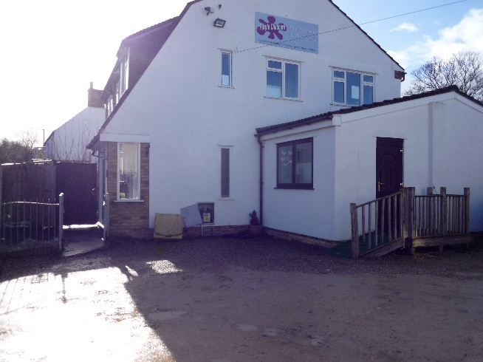
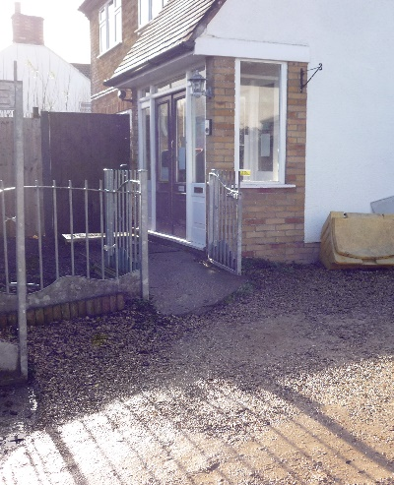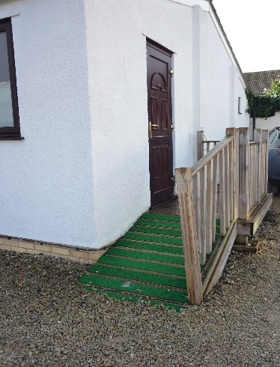
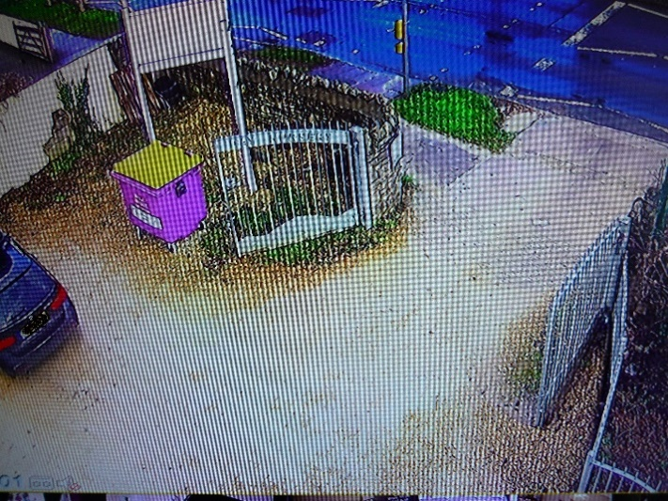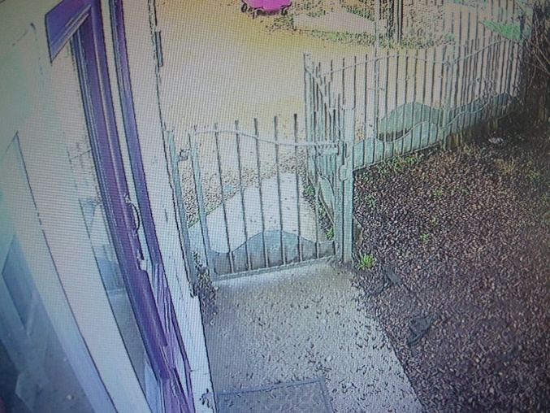
Our rooms and children’s toilets.
- Our layout has been carefully planned and designed by the owners to enable easy access to the resources
- It enables the children to move easily from one activity to another without encountering any problems.
- We understand that some children and adults that come to our setting may require specialist help and therefore we are prepared to undergo any necessary changes to ensure we offer such support.
- We have easy access to the children’s toilets and downstairs rooms.
- Each of our room’s entrances are wide to ensure easy access to all children. Including wheelchair users and those that may use crutches.
- Our children’s toilets also have changing facilities for the younger children and those that are not yet using toilets independently.
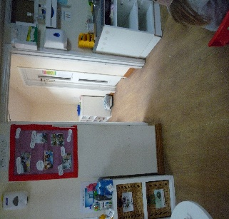
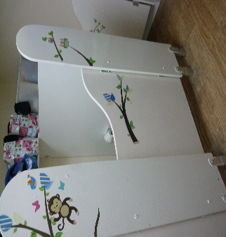
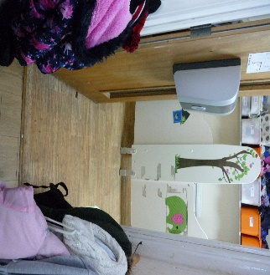
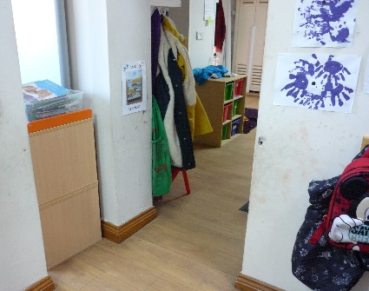

Garden access
- We want all children to access curriculum opportunities indoors as well as outdoors

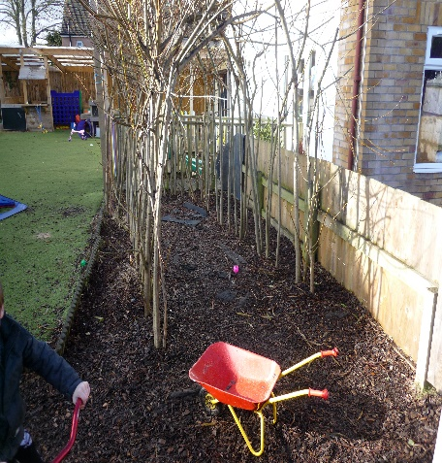
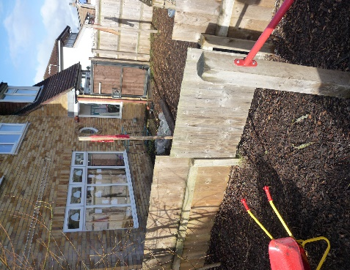
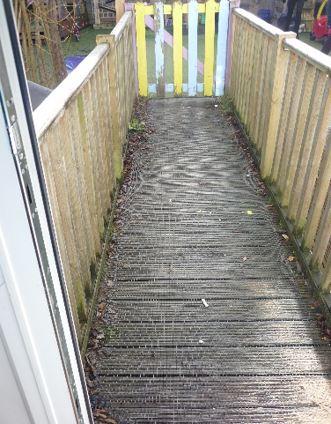

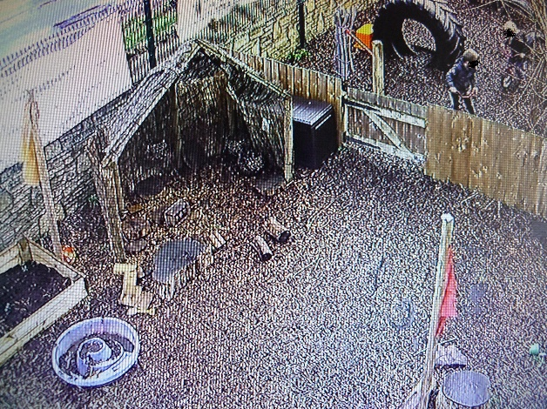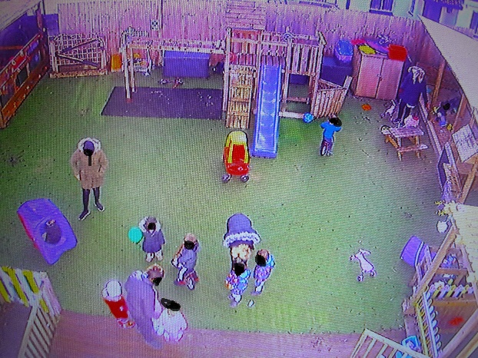
Access to learning.
- Educational Inclusion
At Purple Childcare Bristol we have high expectations of all our children and aim to offer excellence and choice, whatever their ability or needs. We aim to achieve this through the removal of barriers to learning and participation. We want all our children to feel that they are a valued part of our nursery community. Through appropriate curricular provision, we respect the fact that children:
- have different educational and behavioural needs and aspirations;
- require different strategies for learning;
- acquire, assimilate and communicate information at different rates;
- need a range of different teaching approaches and experiences.

How do we identify if a child needs extra help with their learning?
We would meet with the parents/carers of a child with specific needs to plan how to make adjustments to ensure accessibility. A risk assessment would also be written with the parents/carers if necessary.
All children have an entitlement to a broad and balanced curriculum, which is differentiated to enable children to:
- understand the relevance and purpose of learning activities;
- experience levels of understanding and rates of progress that bring feelings of success and achievement.
Observation helps us inform our practice, by observing a child we can learn about their interests and motivations. This enables us to tailor the environment to them and extend their learning using things they find interesting.
Liaison with parents helps us set up the children’s starting points that demonstrate what the children’s current interests and needs are.

Purple Childcare use an online learning journal system. The staff at Purple Childcare and family members designated will be the only people who have access to our children’s learning journal.

The children’s online learning journals contains:
- Children’s recorded observations
- Photographic evidence and videos that support an observation
- Detailed assessments of starting points and continual monitoring of children’s progress

- We undertake careful planning to ensure language support is available to as many children with English as an additional language as possible.
Therefore it is a part of our routine in pre-school room to have a story time in a different language of the children that come to our setting. We have staff that speak fluent Polish and Spanish and they teach the children some key words from the story that was read at story time.
Identifying and assessing SEN for young children whose first language is not English requires particular care. Early years practitioners look carefully at all aspects of a child’s learning and development to establish whether any delay is related to learning English as an additional language or if it arises from SEN or disability. Difficulties related solely to learning English as an additional language are not SEN.
- Careful consideration is given to the planning of learning to enable as much access as possible
The Early Years Foundation Stage is our starting point for planning that meets the specific needs of individuals and groups of children. When planning, staff set suitable learning challenges and respond to children’s diverse learning needs. Some children have barriers to learning that mean they have special needs and require particular action by the nursery.
Children may have Special Educational Needs either throughout or at any time during their nursery development. Our policies ensure that curriculum planning and assessment for children with Special Educational Needs takes account of the type and extent of the difficulty experienced by the child.

Who will be working with my child and what are their roles?
At our setting we share information through a key person. This means parents/carers can always speak to the same person about their child’s progress, needs and any concerns that they may have. As a team, we work closely with each other to share best practice and to have good awareness and knowledge of all our children and their needs. We have strict guidelines about confidential information for staff to follow which can be seen in our policies. If parents have specific needs or impairments of any kind, we will work with the parents to communicate in a way which is effective for them. We also work in partnership with the Early Years Portage and Inclusion team, Speech and Language Therapists, physiotherapists and CAMHS.
Our Team
Manager/safe guarding lead - Felicity Shapter
Deputy Manager/SENCo – Gemma Barnes
Deputy safeguarding lead / Lower Pre-school Room Leader – Naomi Harris
Upper Pre-school leader – Gemma Barnes
Pre – school Practitioner/ 1:1 SEND support – Daniella Powell
Practitioner/ 1:1 SEND support – Parys Bravo
Practitioner/ 1:1 SEND support – Trystan Watkins
Practitioner – Zamira Fuller
Toddler room leader - Maria Reira – Gonzalez
Toddler room practitioner –Dora Horavath / 1:1 SEND support
Baby Room Leader – Vanessa Hendry
How will I be able to raise any concerns I may have regarding my child’s development?

At Purple Childcare Bristol we value parent’s partnership and therefore we aim to involve the parents in their child’s learning and development as much as possible. Each month we share the monthly planning form with all parents, including what celebrations and activities the children will be taking part in and we also share some ideas with the parents of what they could be doing at home.
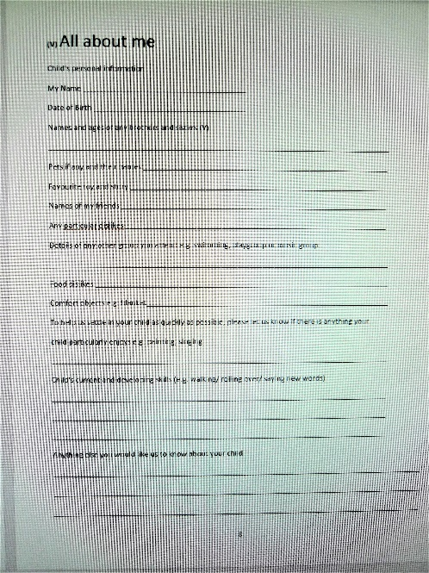
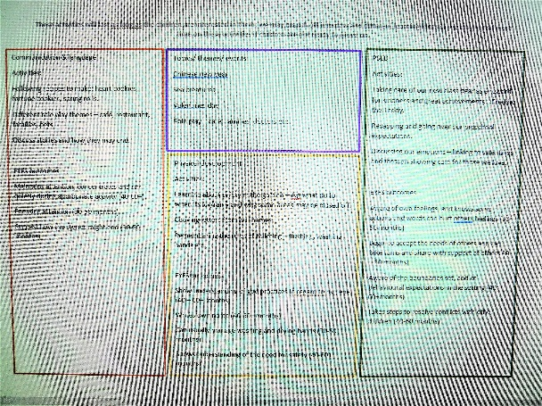
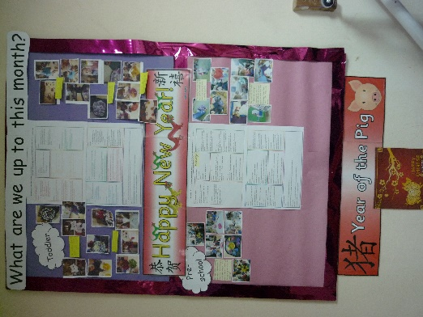

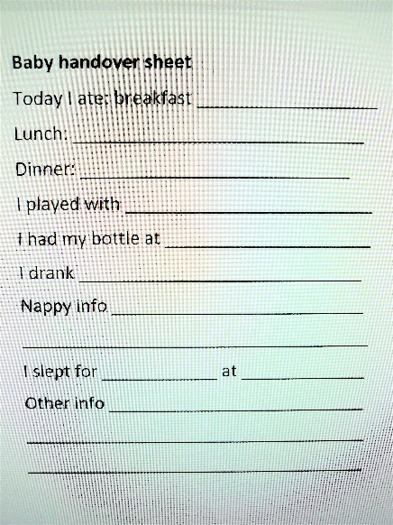
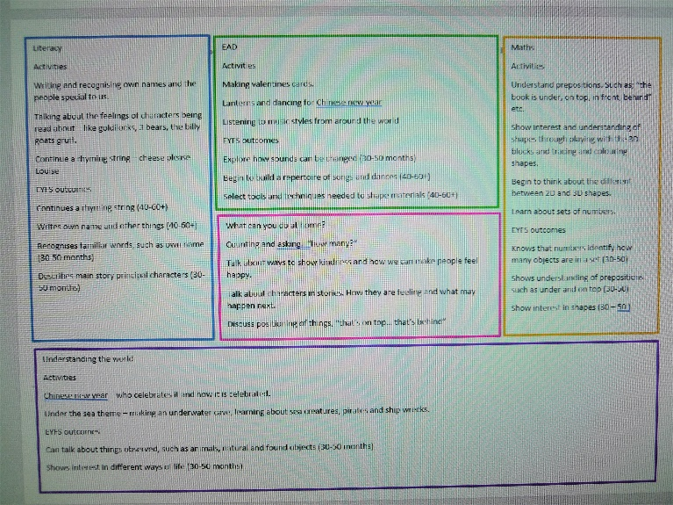

As soon as your child starts at Purple Childcare they will be assigned a key person. The key person will be responsible for planning for the children and monitoring their progress and will likely know them the best. As a small nursery however, it is also likely that all staff members will have some contact with the children as we all take an interest in all of the children in our care.
- Settling in period
Wherever possible the key person will be with the child for their settling in periods and complete a starting points form with the parent. This provides a good opportunity to discus any concerns or needs of the children with the parents and the child’s new key person / room leader.
- Key person and daily feedback
When the children come in to the nursery all staff ask how the children have been and ask if there is anything that the parents would like to let the staff know about, i.e. any sleep issues, health concerns or even things they have done at home and enjoyed. The Key person will also try to be at the door to speak to the parents at hand over and pick up times. If the key person is not available at these times then information about the children’s day will be passed onto another member of staff who will discuss it with the parent. When children’s transition from room to room it is likely that their key person will change.
- Children’s online learning journals
Each parent is assigned to their child’s online system that we use for tracking children’s learning and development – Tapestry. The parents have access top view any observations of their own children only and can contribute to it by sharing their comments and add their own observations from home. It enables the parents to be fully involved and well informed about their child’s progress.
- Summative assessments and 2 year Progress Checks
Each key person is responsible for tracking their key children’s learning and development. This involves the termly summative assessments which are completed on the basis of all types of observations gathered on the children over that term. Summative assessment and progress checks are completed on Tapestry and are then printed out for the parents to read and sign and keep a copy for own records. The key person discusses the details with the parents and explains the next steps that will be taken in order to ensure of the continuous progress.
- Parent’s evenings, meetings and open days
At Purple Childcare we hold a parent’s evening twice a year, where the parents can address any concerns with their child’s key person. We also provide an open day over the summer before the new group of children joins in full time and a Christmas and Summer fairs, which are another opportunity for the parents to meet with their child’s key person and be involved in their child’s nursery life and learning.
We will meet you to talk about support, progress, concerns, and next steps planned with you, through the graduated approach (assess, plan, do, review). These meetings will happen based on each child’s specific needs. For example, one child may need frequent meetings to support needs, and others may just need a catch up every so often 😊
What is the settings approach to supporting different children’s needs and how will that help the children?
- All children are valued as individuals
Staff use a range of strategies to meet children’s Special Educational Needs. Learning and activities have clear learning objectives, we differentiate work appropriately, and we use assessment to inform the next stage of learning.
We support children in a manner that acknowledges their entitlement to share the same learning experiences that their peers enjoy. Wherever possible we do not withdraw children from the nursery situation. There are times, though, when to maximise learning, we ask the children to work in small groups, or in a one-to-one situation outside the main learning environment.
Individual Education Plans (IEPs), which employ a small-steps approach, feature significantly in the provision that we make in the nursery. By breaking down the existing levels of attainment into finely graded steps and targets, we ensure that children experience success. The SENCO and the managers hold regular meetings to review the work of the nursery in this area. The SENCo monitors the progress of children with Special Educational Needs termly and discusses findings with all staff and parents.
- Planning the activities
All room Leaders work with the staff within their room to plan for the children’s provision, we always use it as a rough guide as we follow the children’s interests and fascinations. The activities we plan for the children may also branch out into something different if the children show a new interest or continue longer with a theme if the children aren’t ready to let go. We also ask the parents if they celebrate or acknowledge a particular festival or event each month which we haven’t noted on the planning, that we share with the parents via email, so we can also include that too.

- Monitoring progress
The key person will continually assess the children’s learning and development, plan for their next steps in learning and if there are any areas that they feel the children may still need to work on they identify them and support the children to make the best possible progress working in partnership with the parents at home also.
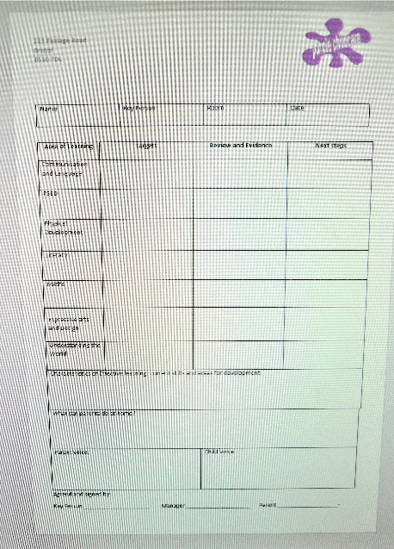
Each key person reviews their key children’s next steps on our development plan once a term or more regularly depending on the targets set up. They also set priority targets that are being monitored daily. If a child makes limited progress their key person will raise a concern with both the child’s parent and the Special Educational Needs Coordinator (SENCO). They will then plan the child’s specific targets that will be reviewed regularly to ensure the appropriate steps have been taken to support the child’s progress.
We work closely with the outside professionals also when required.
This may include an Early Years Portage and Inclusion Specialist, a Speech and
Language Therapist, Educational Psychologist, Occupational Therapist, Health
Visitor or Paediatrician.

Specific targets or strategies may then be used which reflect the advice given
from an appropriate professional. There strategies may be carried out in a 1:1
situation, playing alongside the child or in a small group activity planned by
the child’s key person.

If a child is supported with the help of an outside professional and has been
identified as having a specific educational need, we would discuss the
development of a Support Plan with the parent.

How is the decision made about what type and how much support my child will receive? And how will I be involved?
We expect all staff to deliver a broad and balanced EYFS curriculum with differentiated learning for children with a range of learning needs. Practitioners will meet the individual needs of all children by delivering personalised learning, development and care.

Our setting receives the government funding for two, three and four year olds. This includes the children with special educational needs and disabilities. Our setting can apply for more funding
If a child has additional requirements we can apply for more funding also. We will fill out an application with the help our team that looks after the child and knows him best. The Early Years Special Educational Needs Panel will decide the allocation of funding using the Bristol Universal Description.
Through this funding we are able to provide 1:1 support for your child and to gain resources that are specifically catered for your childs needs
How will I know my child is making progress in their learning?
Before the children start attending the nursery, their new key person will spend some time with the children’s parents during the initial visit to get to know the children and ask for their developments. Those developments (written on the child’s development plan) will be our starting points from which we plan activities to ensure each child continuous to develop their skills. Each term the child’s development plan is reviewed, the new next steps are being set up or different strategies if the child did not show as much progress as it was anticipated. We then share a copy of the development plan with the parents to ensure they are fully involved and discuss possible activities at home to work in partnership with the parents. We also have a parent’s evening when each parent has a 15minute slot with their child’s key person. The staff then discuss the child’s progress in detail, raise any concerns they may have, regarding progress and milestones.
If your child has a Support Plan, this will be reviewed more regularly if needed. The progress children are making is compared to the targets set out in the plan. The targets are set by all professionals that work with the child.
What training have the staff supporting children with SEND had or are having?
Felicity Shapter (manger) is a qualified teacher and behaviour analyst for children with learning difficulties and is excellently placed to help children overcome barriers to learning. Gemma Lawrence (Deputy manager/SENCo) is a qualified SEND teacher and qualified Early Years SENCo. She has 13 years’ experience working with children with additional needs and regularly engages in specific training to develop her understanding and knowledge.
Our staff have training in: Makaton, developing speech and language, creating an enabling environment in which the children develop their skills, alongside many more courses that benefit the children. The staff bring their handouts which are made accessible to all staff should they wish to. The team also discusses any training during their monthly team meeting to ensure all staff keep up to date with all requirements etc.

Autism awareness , children mental health visuals

At Purple Childcare we strive to do the best for all children and work collaboratively with parents and professionals to achieve the best outcomes for your child. We always seek permission before seeking advice from others or developing individual education plans for your child.
There is a staff Training log in place and we encourage the staff to develop their professional skills.
The staff skills are being monitored through peer-on-peer observations as well as formal observations which are completed by the management team.

How does the setting manage the administration of medicines and manage personal care?
We have a Medication Policy in place. A suitably qualified member of staff will be responsible for giving medicines to your children only. We are happy to give prescribed medication in accordance with the guidance of a doctor, if a permission slip has been signed and verbal confirmation has also been made on the day either in person or over the phone. Parents will have to sign a form at the end of the day to say which medicines have been given. You must provide the medication yourself and the bottle must be clearly labelled with the child’s name and prescription information.
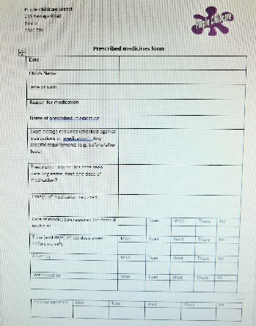
In the case of non-prescribed medication exceptions may be made in certain circumstances (such as specific medical conditions e.g. a history of febrile seizures) and under guidance from the child’ GP, paracetamol may be administered in the case of a high temperature with parental permission and on the understanding that the child must be collected from nursery as soon as possible.
In the case of giving antibiotics or any medication for the first time a child must stay at
home for 24 hours after the first dose to check for allergic reaction.
A suitably qualified member of staff will be responsible for the storage of all medicine and
ensuring the expiration dates. The storage of medication will be in a locked box.
If your child has a long-term medical condition please give as much information to the
nursery as possible. All medicines must be in their original containers and have product
instructions. We wish to accommodate your child as much as possible, please let us know
in advance if your child takes medication which requires any training.

How will my child be prepared to move onto the next stage within the setting or onto school?
We aim to provide as smooth transitions as possible therefore we implemented a free-flow system between rooms in our setting for the children to experience different age groups. We encourage the schools to organise a visit also, either by visiting the children in their home or arranging a visit to the nursery to ensure the children know who their teacher is and for the teachers to get to know the children better.

